Introduction to Data Collection in Computing Research
- To gather accurate, relevant, and sufficient data to answer the research questions or test hypotheses.
- Classification
  - Primary Data: Directly collected (surveys, interviews, experiments, observation, sensors, system logs).
  - Secondary Data: Pre-existing datasets (e.g., Kaggle, UCI, government open data, GitHub repositories).
- Key Principles
  - Relevance to research objectives.
  - Representativeness of the population.
  - Ethical and legal compliance (consent, anonymization).
Example
A student predicting network intrusion using the NSL-KDD dataset—secondary data. Another team interviews software developers about Agile tool use—primary data.

2. Data Collection Methods
Method | Description / Variants | Advantages | Disadvantages / Challenges | Tips / Best Practices
Questionnaires / Surveys | Paper, online (Google Forms, Qualtrics, SurveyMonkey), telephone, face-to-face | Can reach many; cost-effective; standardized responses; ease of quantification | Low response rates; superficial responses; potential misinterpretation; response bias; static instrument | Pilot test; use clear, neutral language; mix closed & open items; include “check questions” for consistency (ResearchGate); incentivize responses; follow-up reminders; translate and back-translate if multilingual
Structured Interviews | Face-to-face, telephone, video call, web chat | Can clarify questions; higher response quality; can probe for elaboration | Time-consuming; interviewer effects (bias); scheduling challenges; costly | Train interviewers; use an interview guide; record (with consent); transcribe; pilot the interview schedule
Semi-Structured / Unstructured Interviews | Open-ended conversational style | Rich, deep data; flexibility; can uncover new themes | Harder to analyze; less consistency across interviews; depends heavily on interviewer skill | Use prompts; ensure good rapport; take memos during interviewing; iterative checking & follow-up interviews
Focus Groups / Group Interviews | 6–10 participants discussing topics | Stimulates interaction; multiple perspectives; efficient way to collect data from several people | Dominant voices may skew discussion; groupthink; scheduling difficulty; confidentiality concerns | Use skilled moderator; prepare a discussion guide; record and transcribe; balance group dynamics
Observation / Ethnographic Fieldwork | Participant vs. non-participant; overt vs. covert; structured (checklists) vs. unstructured | Captures behavior in context; real-time data; less reliance on self-report bias | Observer effect (reactivity); selective perception; access and ethics issues; data recording burdens | Use structured observation schedules; train observers; use multiple observers; wash out biases; maintain field notes; use video/picture as supplements
Usability / Lab Experiments / Controlled Observations | Task-based experiments, A/B testing, lab studies | High internal validity (control); causal inference possible; precise measurement | Low ecological validity; limited generalisability; resource-intensive; participant recruitment challenge | Randomize, counterbalance; control extraneous variables; pilot tasks; simulate realistic context when possible  (randomization, standardization (all experience same), matching (based on characteristics), and statistical controls)
Case Studies | In-depth study of single “case” (organization, system, user group) | Deep, contextualized insight; can accommodate complexity | Limited generalisability; risk of subjectivity; intensive data management | Use multiple sources (triangulation); document boundary of case; clarify how case was selected (ResearchGate)
Document / Archival / Secondary Data | Existing texts, logs, reports, system logs, social media archives, APIs, census data | No respondent burden; cost-effective; longitudinal possibilities; good complement to other methods | Data may be incomplete, inconsistent, or biased; access issues; unknown quality of original data | Assess source reliability; check metadata; document data provenance; triangulate with primary data
Digital Trace / Log Data / Sensors / Instrumentation | Web logs, telemetry, IoT sensors, clickstream, API logs | High precision; passive collection; often large-scale; unobtrusive | Privacy & ethics risks; missing contexts; interpretation ambiguity; data cleaning overhead | Plan variables to collect; anonymize/pseudonymize; time‐stamp and synchronize; validate sensor calibration; complement with qualitative/contextual data
Diary / Journals / Experience Sampling (ESM) | Participants record experiences at set intervals (e.g. via mobile app) | Captures lived experience; temporal dynamics; reduces recall bias | Participant burden; missing entries; superficial entries; compliance issues | Use reminders; make interface easy; limit frequency; incentivize; triangulate entries with other data
Delphi Panels / Expert Elicitation | Iterative rounds of expert questionnaires | Access expert knowledge; refine consensus over rounds | Expert bias; attrition across rounds; slow process | Define clear criteria for experts; maintain anonymity of responses; provide feedback across rounds

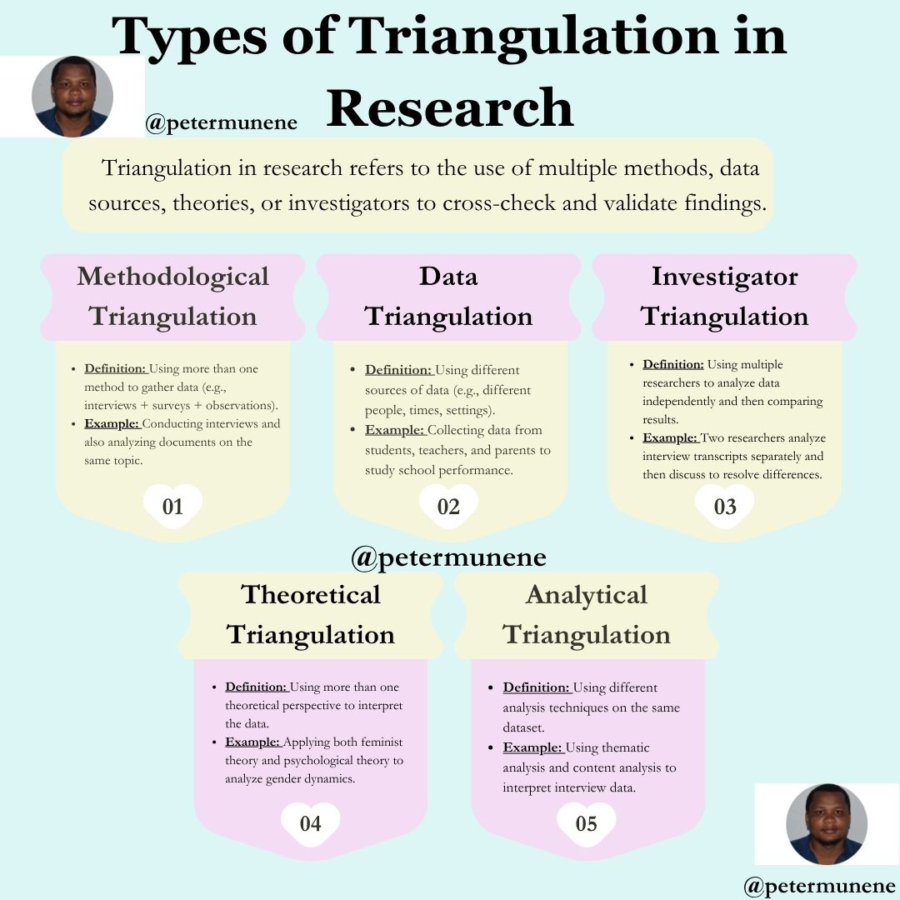
SECONDARY DATA COLLECTION
Secondary data refers to information that already exists — collected for other purposes but reused for research.
Sources
- Public datasets: Kaggle, UCI Machine Learning Repository, government open data portals.
- Institutional records: NSBM databases, ministry reports.
- Published research: Journal articles, theses, meta-analysis datasets.
- Digital footprints: Social media posts, GitHub commits, web analytics.
Advantages
- Time and cost-efficient.
- Enables longitudinal or large-scale analysis.
- Often more objective and reliable if collected systematically.
Limitations
- Data may not fit your exact research questions.
- Missing variables, unknown sampling methods.
- Possible bias or outdated data.
Tips for Using Secondary Data
- Check source credibility and collection purpose.
- Document metadata (when, how, by whom data collected).
- Verify completeness and consistency.
- Clean and preprocess carefully (handle missing data).
- Cite original sources properly.
Example: Using Kaggle’s “Credit Scoring Dataset” to predict customer creditworthiness in a Data Science project.

3. Sampling Techniques & Experimental Design
Type | Definition | Example (Computing Research) | Pros | Cons
Simple Random Sampling | Every participant has an equal chance | Selecting 100 students randomly from NSBM database | Unbiased, easy analysis | Requires full population list
Stratified Sampling | Population divided into subgroups (strata) | Selecting 50% male and 50% female app users | Ensures subgroup representation | More complex to manage
Systematic Sampling | Every nth record chosen | Selecting every 10th GitHub repository from a list | Simple, evenly distributed | Periodic patterns may bias
Cluster Sampling | Groups (clusters) randomly selected | Choosing 5 universities and surveying all their students | Cost-effective for large areas | Lower precision
Convenience Sampling | Using available participants | Surveying classmates about social media use | Quick, easy | Not representative
Purposive Sampling | Selecting specific individuals with expertise | Interviewing data scientists about ML ethics | Focused, in-depth | Subjective bias possible
Snowball Sampling | Participants recruit others | Getting referrals from one AI researcher to another | Accesses hidden populations | May create homogenous samples

Experimental Design
Design Type | Explanation | Example
True Experiment | Random assignment to control & test groups | Testing if AI-based tutoring increases student scores
Quasi-Experiment | Groups not randomly assigned | Comparing two classrooms using different teaching tools
Field Experiment | Conducted in real-world settings | Testing a new LMS in actual classrooms
A/B Testing | Comparing two versions of an interface | Testing button color impact on click rate
Within-Subjects | Same participants in both conditions | Same users test two dashboard layouts
Between-Subjects | Different participants for each condition | One group uses chatbot A, another chatbot B

4. Validity, Reliability & Generalisability
Concept | Meaning (Simple) | Example | How to Improve
Validity | Accuracy – Are you measuring what you intended? | Does your “stress” questionnaire truly measure stress, not workload? | Align questions with theory, pilot test, use expert review
Reliability | Consistency – Will you get the same results if repeated? | A usability test gives the same satisfaction score when repeated | Standardize procedures, train data collectors
Generalisability | Applicability – Can results be applied elsewhere? | Can findings from NSBM students apply to all Sri Lankan universities? | Use larger, diverse samples; describe context clearly

Validity – “Does it measure what it is supposed to?”
Type | Description | Computing Example
Internal Validity | Control of confounding variables | Ensuring identical test conditions in usability experiment
External Validity | Generalisation to other contexts | Can the UI results apply to other user groups?
Construct Validity | Alignment between concept and measurement | Does the “usability score” truly represent usability?
Content Validity | Coverage of intended domain | Survey includes all aspects of user satisfaction

Reliability – “Consistency of measurement”
Type | Explanation | Example
Test–retest | Same results over time | Running algorithm twice → same accuracy
Inter-rater | Agreement among evaluators | Two coders tag themes identically in NVivo
Internal consistency | Items in questionnaire measure same concept | Cronbach’s α ≥ 0.7

Tips to Improve Reliability
- Use clear protocols.
- Calibrate instruments.
- Train observers.
Generalisability
- Extent to which findings can apply to wider settings or populations.
- Influenced by
  - Sampling strategy.
  - Research context.
  - Cultural/technological differences.
- Example: Predictive model trained on Sri Lankan students—can it apply to global learners?

5. Ethical Considerations in Research
- Respect for Persons - Informed consent; right to withdraw.
- Beneficence - Maximise benefits, minimise harm.
- Justice - Fair participant selection.
- No Harm Principle - Avoid physical, emotional, or social harm.
- Confidentiality & Anonymity - Encrypt data; remove identifiers.
- Data Management - Secure storage, backups, retention policies.
- Plagiarism & Authorship Ethics - Proper citation, use of plagiarism checkers.
- Data Security - Store securely, follow retention policies, anonymize where needed.
- AI-Ethics (Computing-specific) -
  - Avoid algorithmic bias.
  - Ensure data privacy and fairness.
  - Acknowledge model limitations.
Example: Collecting face-recognition data from minors → requires guardian consent and anonymisation.

6. Quantitative vs. Qualitative Data Analysis
Aspect | Quantitative | Qualitative
Nature | Numeric | Textual, Visual
Goal | Measure & test | Explore & understand
Tools | Excel, SPSS, R | NVivo, Atlas.ti
Analysis | Descriptive & inferential stats | Thematic or content coding
Output | Graphs, tables, models | Themes, narratives, concept maps

7. Ensuring Quality in Research
- Triangulation: Use multiple data sources or methods.
- Pilot Testing: Identify flaws in instruments early.
- Peer Review / Expert Validation: Strengthens construct validity.
- Transparency: Document procedures for reproducibility.
- Replicability in Computing: Share code, data, version control (GitHub, OSF).

Discussion Questions (1.5 Hours)
- Identify examples of poor validity or unethical practice.
- Pick a preferable Kaggle dataset and check for reliability issues, generalizability and validity (?
- Get into 10 member groups, Think like 05 of you are from Ethics Review Board, other 05 are researchers defending data-collection methods. Start talking about each once research idea and record your concerns and the questions arose. Practice solutions.

References
- Creswell, J. W., & Creswell, J. D. (2018). Research Design: Qualitative, Quantitative, and Mixed Methods Approaches. Sage.
- Saunders, M., Lewis, P., & Thornhill, A. (2019). Research Methods for Business Students (8th ed.). Pearson.
- Flick, U. (2018). An Introduction to Qualitative Research (6th ed.). Sage.
- Cohen, L., Manion, L., & Morrison, K. (2018). Research Methods in Education. Routledge.
- Bryman, A. (2016). Social Research Methods (5th ed.). Oxford University Press.
- Yin, R. K. (2018). Case Study Research and Applications: Design and Methods. Sage.
- Babbie, E. (2021). The Practice of Social Research (15th ed.). Cengage.

